# CS 255 System Design Document

## UML Diagrams

### UML Use Case Diagram

### UML Activity Diagrams

### UML Sequence Diagram

### UML Class Diagram

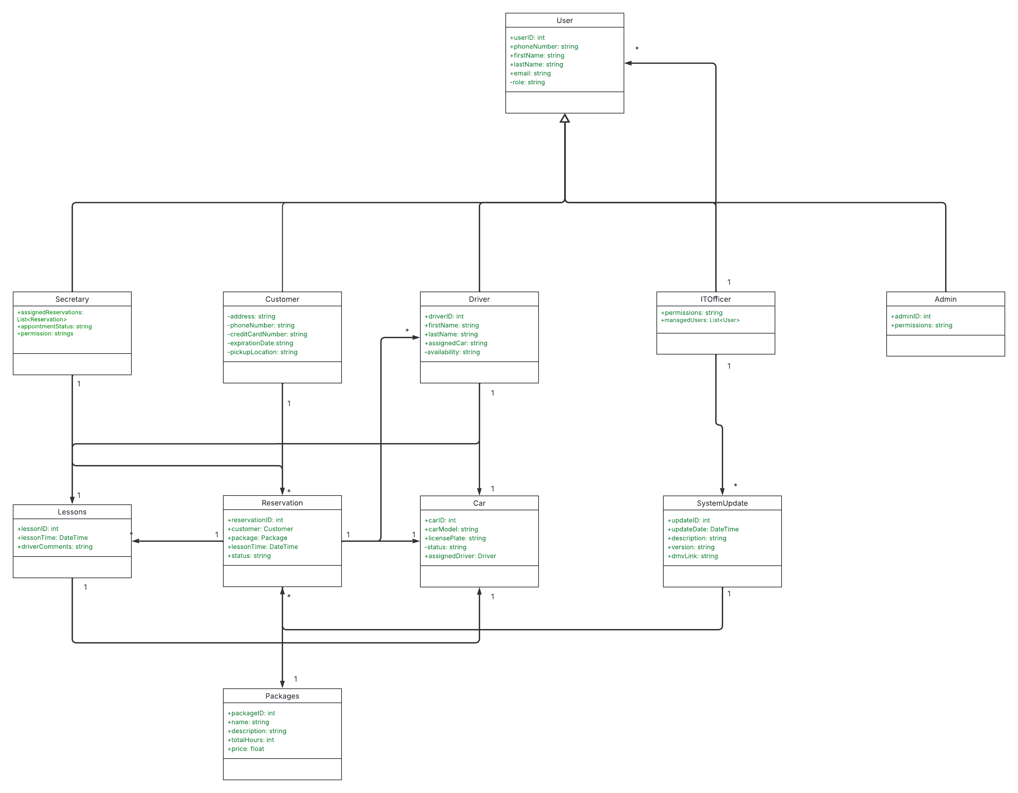

## Technical Requirements

The hardware requirements for the DriverPass system will mainly involve servers to host the web-based platform, with the option to utilize cloud infrastructure for scalability. A cloud-hosted environment, such as Microsoft Azure, will provide the flexibility needed for seamless scaling as user demands grow. The servers should have robust storage capabilities to manage large volumes of data, including customer records, reservations, and driving lesson logs. Additionally, the network infrastructure, which is designed to support reliable internet connectivity, will give you confidence in the system's performance, ensuring that users can access the system without interruptions. Backup servers and disaster recovery systems should be implemented to guarantee business continuity.

For users, client hardware will include devices such as desktops, laptops, and mobile phones that can access the web platform through a browser or a dedicated mobile app.

In terms of software requirements, the system will need a web development framework, such as ASP.NET Core for the back end and ReactJS or Angular for the front end, to create a responsive and intuitive user interface. The back-end will rely on a relational database management system (RDBMS), like Microsoft SQL Server or MySQL, for secure and efficient storage of customer data, reservations, and employee roles. To ensure your data is secure, the system will integrate SSL/TLS encryption for HTTPS connections. For user management, the system will integrate with Azure Active Directory for role-based access control. Power BI may be utilized to generate business intelligence reports, and Azure Backup will provide a secure disaster recovery solution.

The infrastructure must also support automatic system updates and real-time synchronization to enable seamless data access across different platforms while minimizing downtime during maintenance.